Information sheet
The recording you will be participating in is part of a dissertation work being conducted at the University of Oulu. The purpose of the research is to examine the way different budo sports are practiced and taught. The research will include recordings from judo, karate, Brazilian ju-jitsu and aikido practice sessions and seminars.
This research is not normative by nature, meaning that it will not evaluate the quality of the teaching or attempt to describe “good” or “bad” teaching methods. Instead, the research will try to show what participants, both teachers and students, actually do in the practice sessions. This research examines how participants move, talk, gesture and take part in teaching and learning. How, for instance, do people show through their bodies, talk, and movement, that they are about to practice a new technique?
This research uses a method called Conversation Analysis to examine the ways of practicing budo sports. Conversation Analysis relies on audio and video recordings taken from real-life interactions. Transcriptions are then produced of these recordings to highlight different details of the interaction. Below are some examples of transcriptions produced from judo and karate practice session.

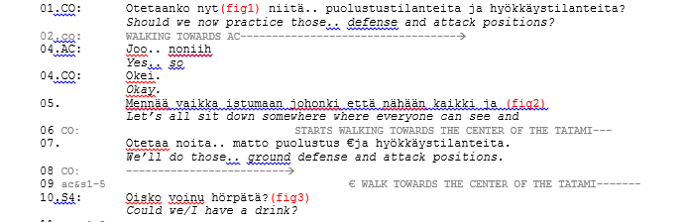

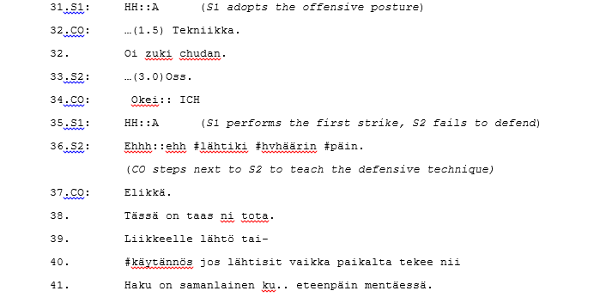

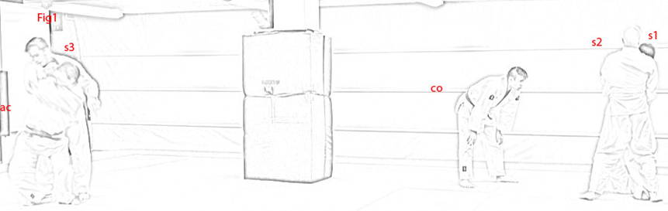
Transcriptions like these, alongside with anonymized images from the recordings (as seen above), will be used when publishing the results of the research.
Thank you for your participation!
If you have any questions regarding the research or the recordings please contact the researcher (Joonas Råman) by e-mail or by telephone. All participants have the right to see and edit the material they appear in, so if you want to review your techniques on video, you are more than welcome to do so.
E-mail: Joonas.raman@oulu.fi
Tel. 050-5723979

